**Name: Dhruv Barot**

**Student id: 101415874**

**Course code: COMP3123**

**Assignment 02**

**Mongo Db Screenshots**

**Screenshot 01:**

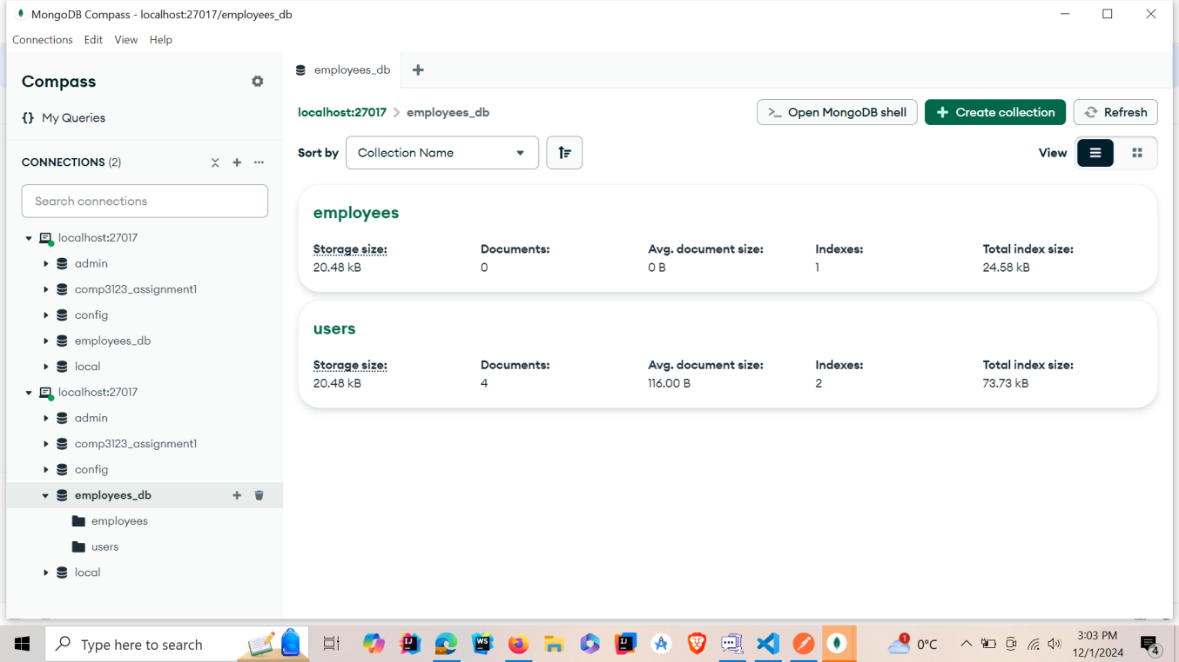

**Screenshot 02:**

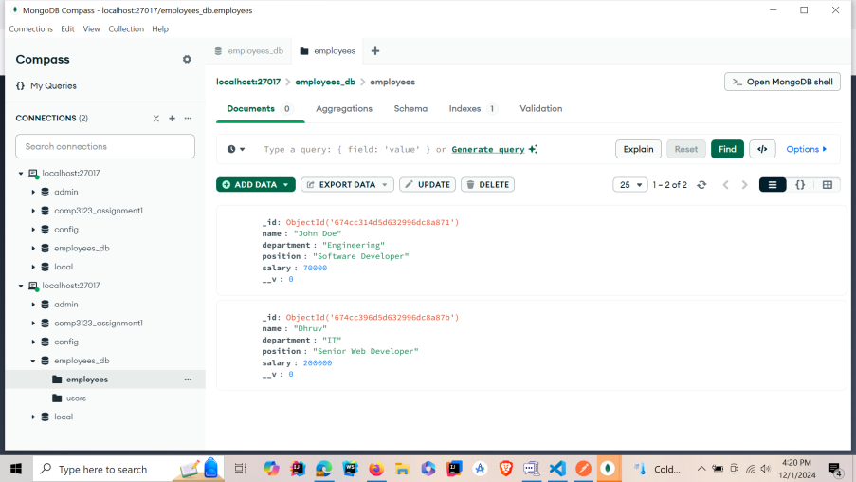

**Screenshot 03:**

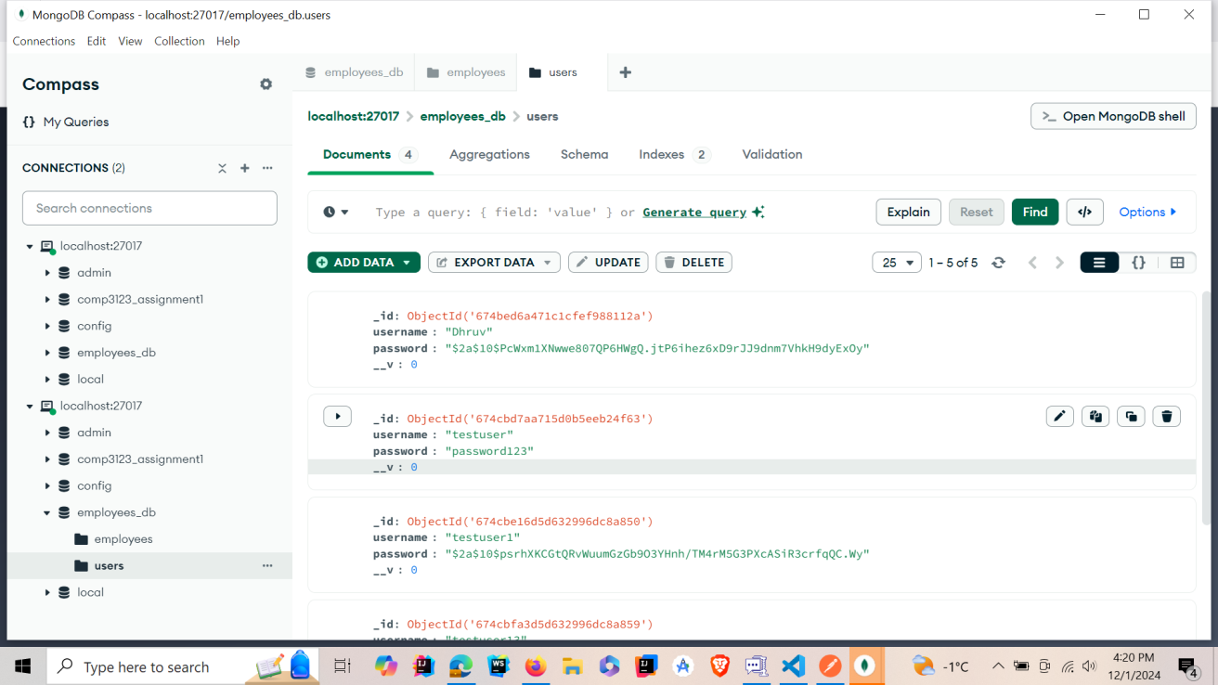

**Postman Photos**

**Screenshot 01:**

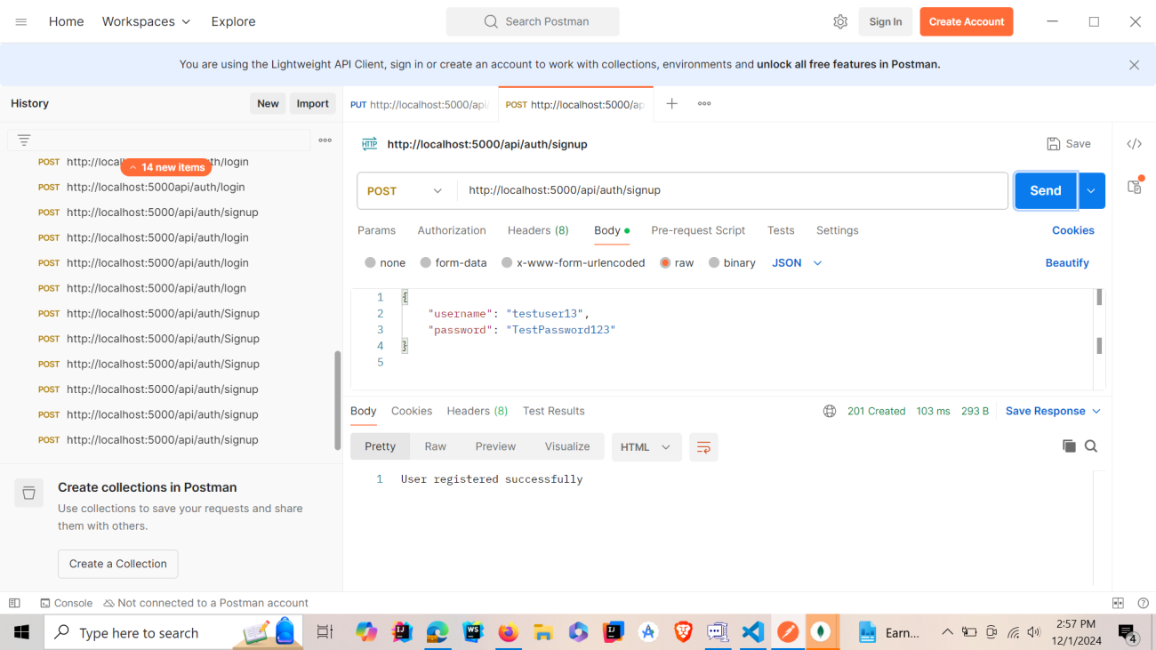

**Screenshot 02:**

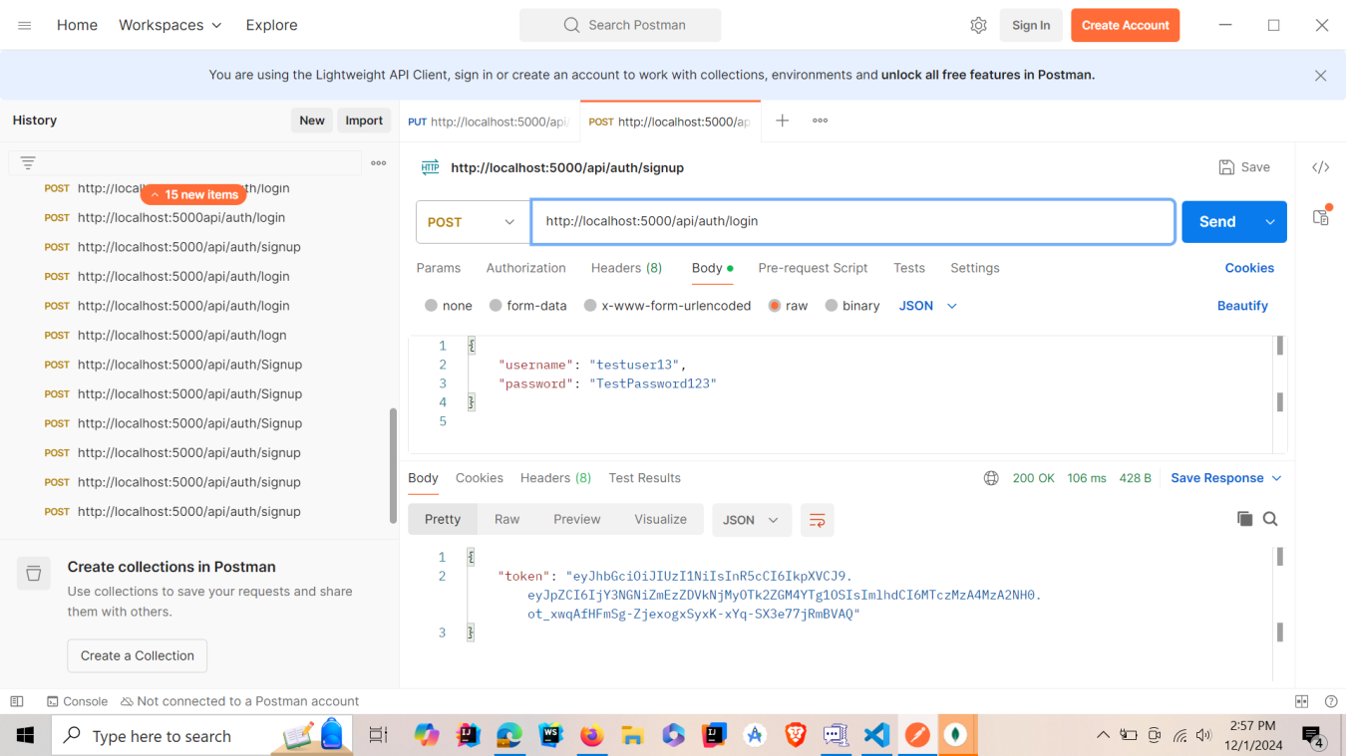

**Screenshot 03:**

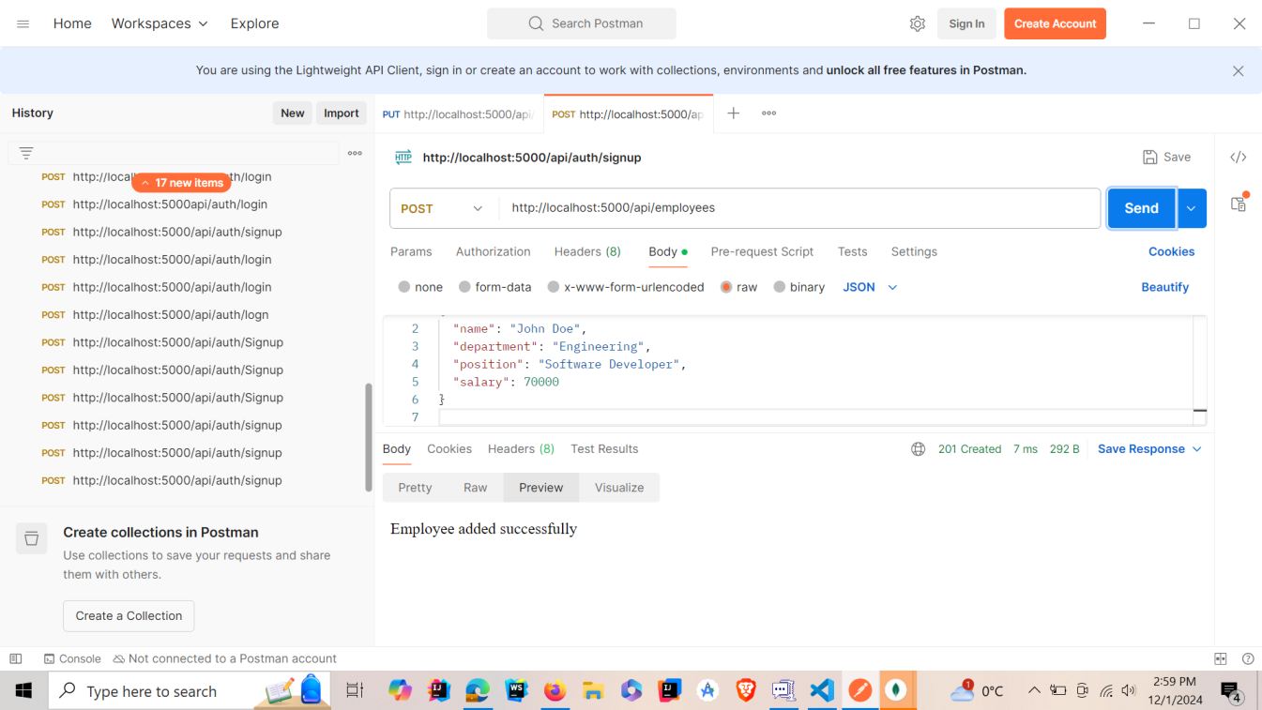

**Screenshot 04:**

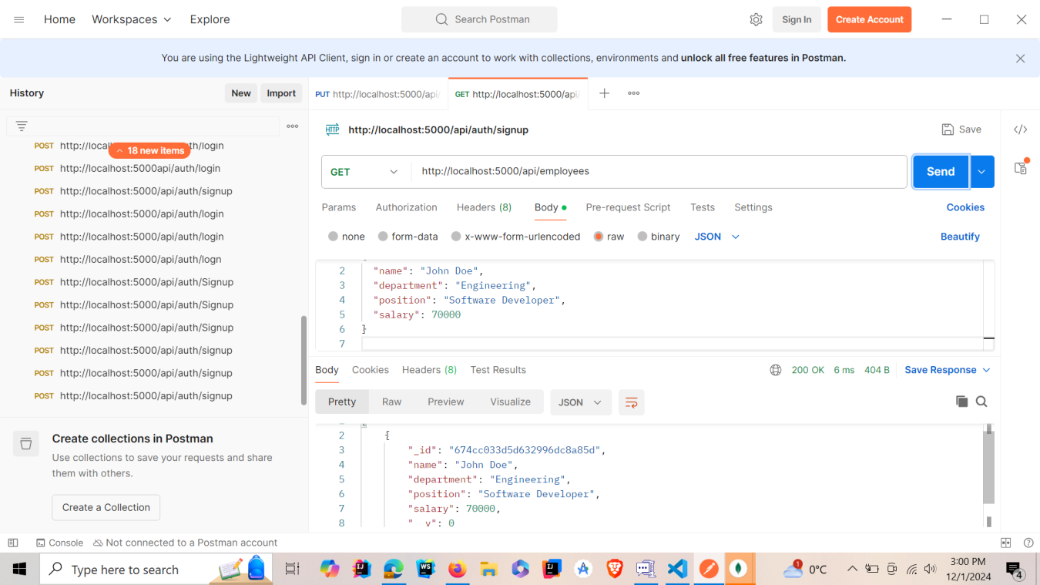

**Screenshot 05:**



**ReactJS app operation screens**

**Screenshot 01:**

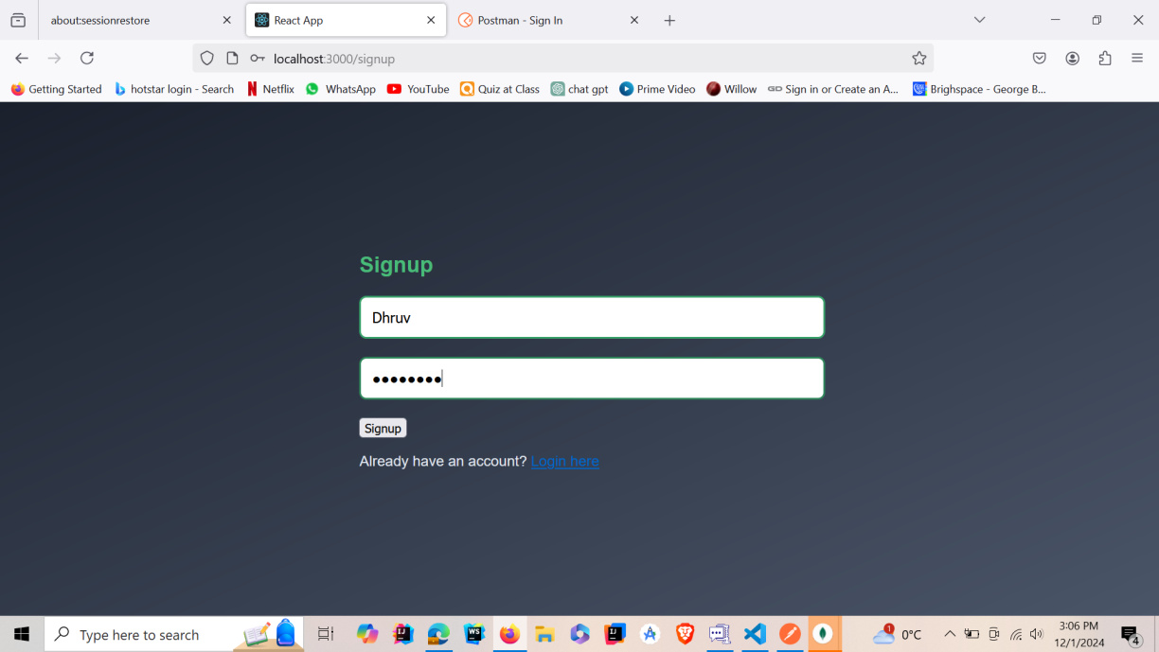

**Screenshot 02:**

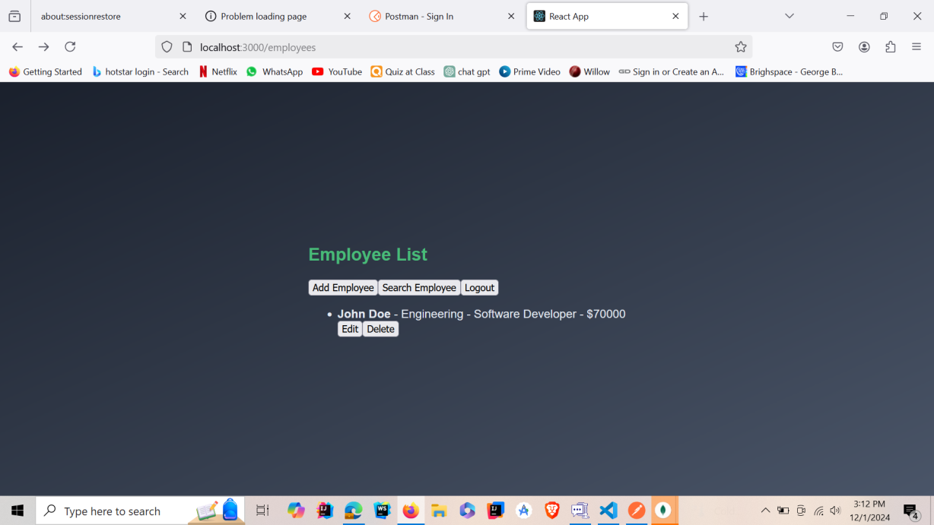

**Screenshot 03:**

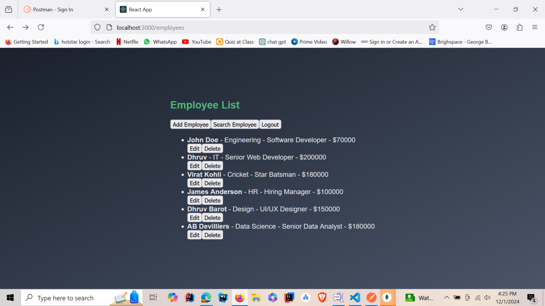

**Screenshot 04:**

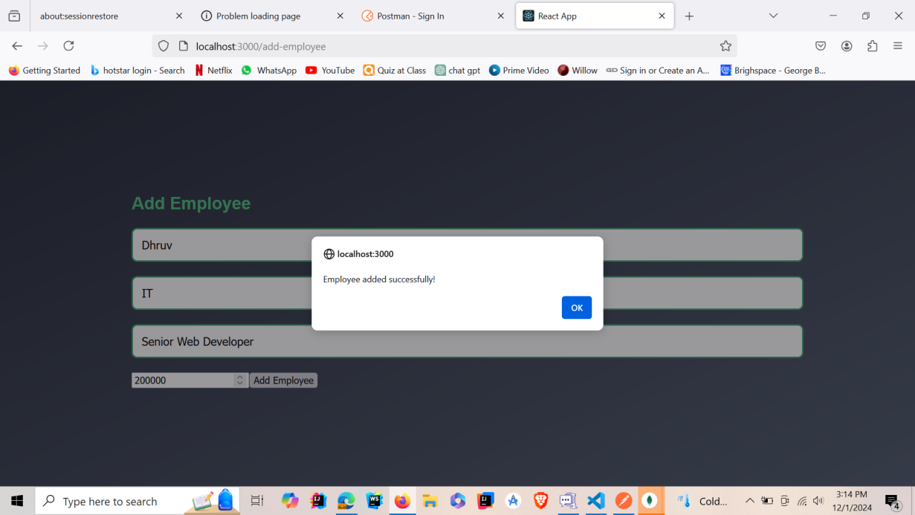

**Screenshot 05:**

